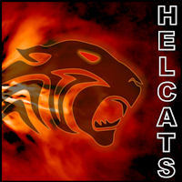

HELCATS First Annual Open Workshop 2015
Abstract Submission Form

Abstract submission for
Session 1: Heliospheric imaging observations of solar wind structure (e.g. CMEs, CIRs, turbulence): introductory and review talks.
Session 2: Debating standards for making CME associations.

Session 3: Remote-sensing/in-situ observations of heliospheric phenomena and their sources and impacts.
Session 4: Development and application of heliospheric observations and techniques for scientific and space weather usage.
Session 5: Future heliospheric and space weather instruments/ missions.

Preference:
Oral Poster

Title
Author(s)
Affiliation, e-mail

Main body of abstract.

